**Project Analysis Document**

**OPENMETEO API FOR**

**UV INDEX EMBED**

**3815 Singleton Blvd, Dallas, TX 75212**

**SOUTHERN SKIN CANCER TREATMENT CENTERS**

**3815 SINGLETON BLVD.**

**DALLAS, TEXAS 75212**



**3/17/2025**

(Project Management Docs didn’t have a template, but I liked the logo and wanted all three to match)

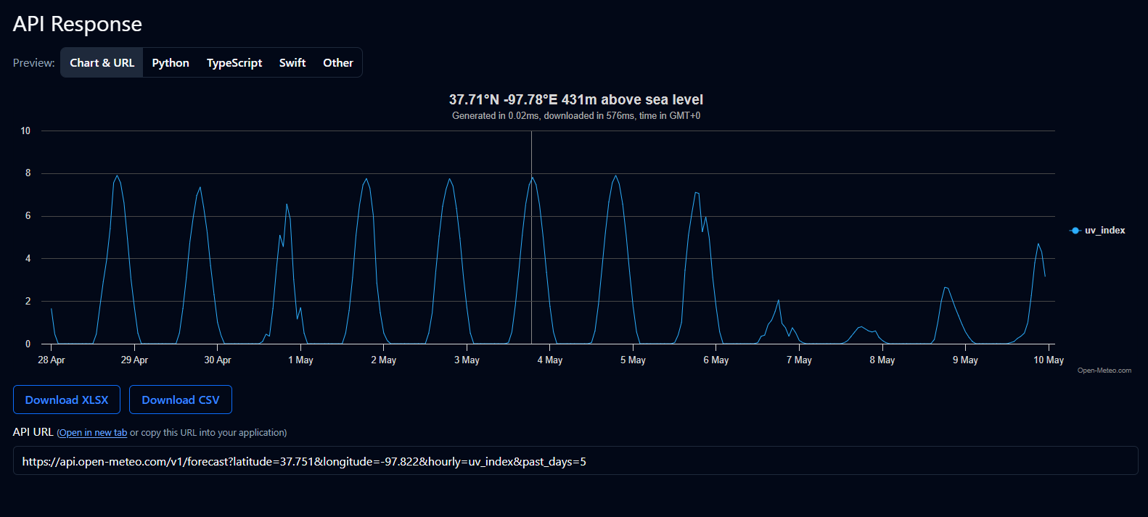

A sample response using longitude and latitude from OpenMeteo API data.

Analysis: OpenMeteo provides a substantially robust API for reporting the specific information the Southern Skin Cancer Technical Institute has deemed necessary. For this project, we recommend and will complete the project using the **uv_index** variable & geocoding API to provide hourly information about the current UV index at a given location. For accessibility and easier customization of the chart so that it can be stylized for SSCTI’s upcoming website, chart.js will be utilized for visualization of the graph. Using the geocoding API provided by OpenMeteo will also allow users to type in their city (ie. Little Rock, Arkansas) instead of utilizing their device’s location data. Using these resources will allow our company to provide it as a simple page content addition with a separate Javascript and Cascading Style Sheet file, that can be easily maintained by future developers.

Considerations:

1. Ensure server delivering website is utilizing HTTPS. This should be a standard security configuration for any enterprise environment.
2. Accessibility: Due to charts being primarily visual elements and not lending itself to users with possible reading impairments, the information should be displayed in a text format as well. This will be implemented via our company, to which SCCTI can choose to implement or not based on their user’s needs. This will be available by default as a checkbox next to the input fields for visual impairment.
3. API Rate limits: Based on estimated user count and due to the nature of the request, a commercial API pricing plan will have to be resolved with OpenMeteo if not already done so, pricing information has been included in the image below. Individual contract and pricing information cannot be confirmed via our company and should be resolved with OpenMeteo:

Summary:

 Based on preliminary research conducted by our company via OpenMeteo API documentation and guidelines as provided by SSCTI, this product is on track and can be completed in the timeline provided in the Charter. All considerations are to be provided and addressed on the side of the appropriate parties. One & three are to be review by SSCTI, as our company does not see an obstacle or issue with a change in the timeline for Consideration two.